RM 294 Optimization Project 1

## Christian Alfonso, Brent Hensley, Jessie Lee, Sungho Park

**Question 1: ROI Table and Load the CSV**

The marketing firms fund allocation for their respective medium is defined in this table.

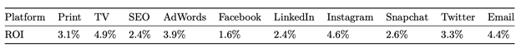

The following graph shows the imported ROI_data.csv file

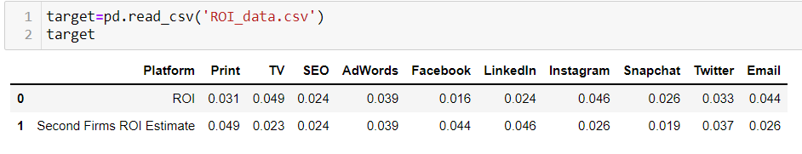

**Question 2: Boss Constraints**

The boss now wants us to specify our budget on 3 constraints: **1.** The amount invested in print and TV should be no more than the amount spent on Facebook and Email. **2.** The total amount used in social media (Facebook, LinkedIn, Instagram, Snapchat, and Twitter) should be at least twice of SEO and AdWords. **3.** For each platform, the amount invested should be no more than $3M.

**Question 3: Linear Programming Formulation**

We formulated the constraints in to the matrix shown below using the following code:

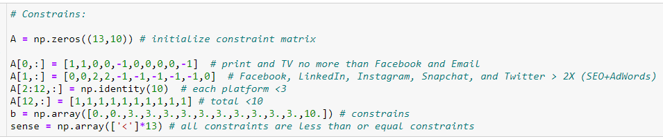

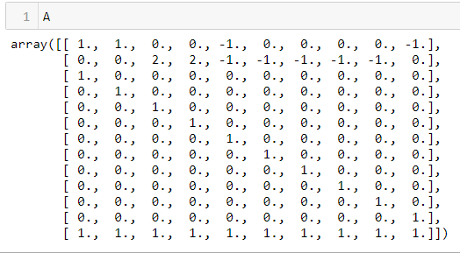

Gurobi produces the following optimal investment, which can be interpreted as spending $3M on TV, $1M on AdWords, $3M on Instagram, and $3M on email, and nothing on other mediums.

**Question 4: Second Opinion**

The boss might be pleased initially, but they still want a second opinion. Below is the fund allocation for the second ROI calculations of the other firm.



**Question 5: Comparing ROI’s**

Below, we have the direct comparison table for the first fund allocation optimization and the second fund allocation optimization to accommodate the change in ROI for each medium. The changes in allocation result in the following shift:

* Dropped funds for TV, Instagram and Email
* Invest in Print, Facebook and LinkedIn
* All others remain the same

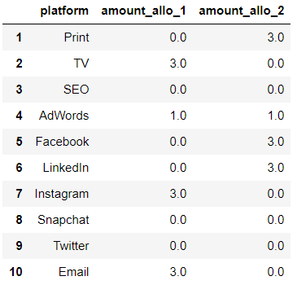

The allocations are not quite the same. If we assume ROI 1 is correct, allocation 1 would see a return of $ 0.456 million while allocation 2 sees $0.252 million. This results in a $0.204 million lower ROI by mistakenly using allocation 2. Inversely, if we assume ROI 2 is correct, allocation 2 would see a return of $0.456 million while allocation 1 sees $0.264 million. This results in a lower ROI of $ 0.192 million by mistakenly using allocation 1.

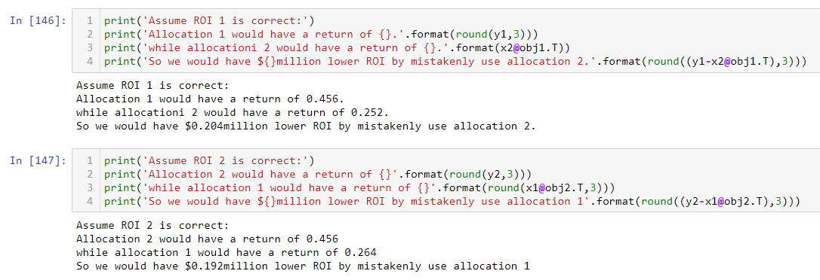

The boss's cap on each of the funds is useful to constrain the allocation because if you lift the cap for each medium, the funds all go to TV and Email, with $5M on each medium.



Additionally, if we vary the funds cap for each medium, we get a very different allocation, however, when it's equal or greater than $5 million, the funds all go to TV and Email.

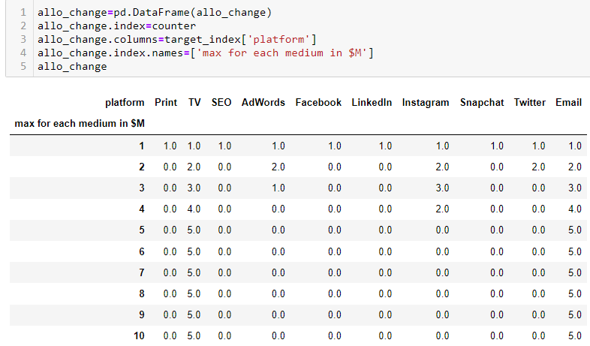

**Question 6: ROI Sensitivity**

The following graph shows the sensitivity of return on variation of ROI assumptions on each medium. The green bar is the basecase ROI assumption, and the purple lines show the ROI range for each medium before it changes the fund allocation. When the purple lines touch the edge of the diagram, it indicates that the fund allocation is insensitive to the change of that particular ROI in that direction, i.e., in the extreme case, even when the ROI increases or decreases to infinity, the allocation won’t change.

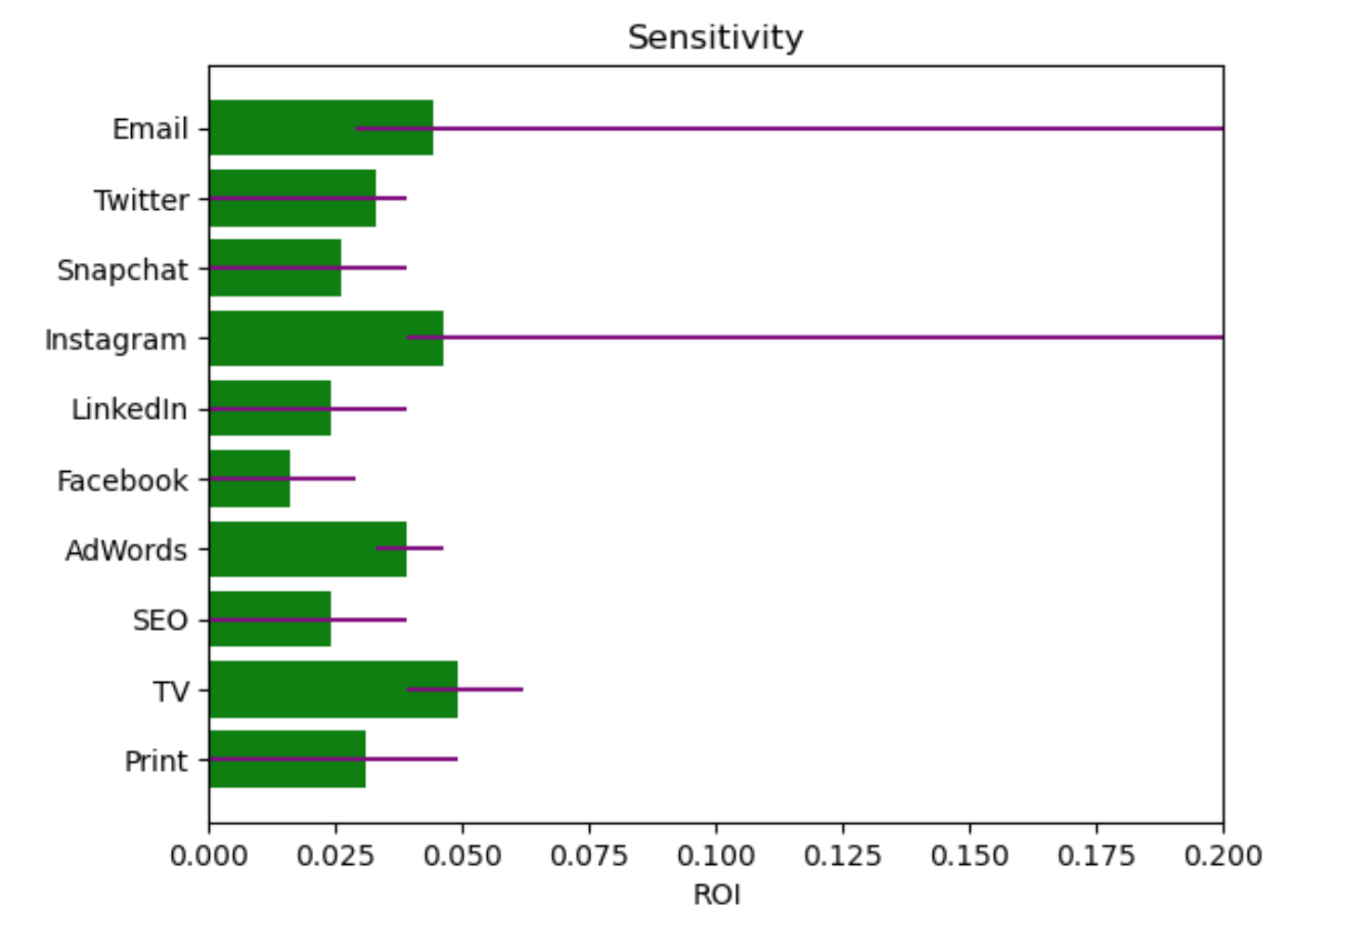

This chart numerically shows what is illustrated in purple above, with **-inf and inf** representing the extreme case of insensitivity (won’t change the allocation even going to infinite large or small numbers).

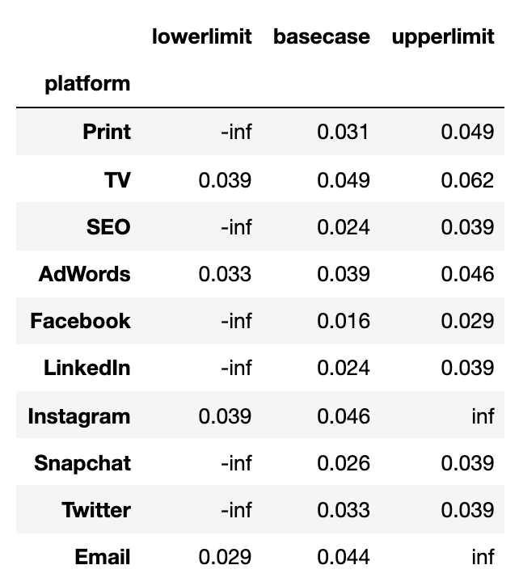

**Question 7: Reinvesting the Returns & Question 8: Budget Stability**

Knowing that the same constraints are in place, and that half of the return can be reinvested, we used the following code to create the constraints and solve for the optimal investment solution for each month.

If we use a **constant ROI to optimize**, we get a **stable fund allocation** of each month as shown on the table.



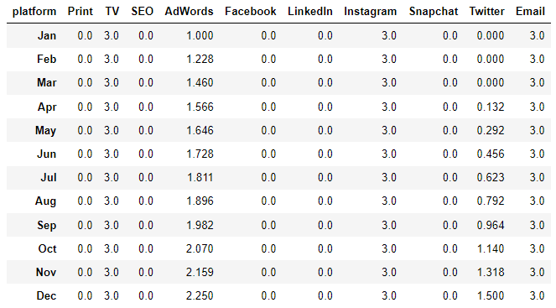

However, if we use **the variable ROI** as shown below:



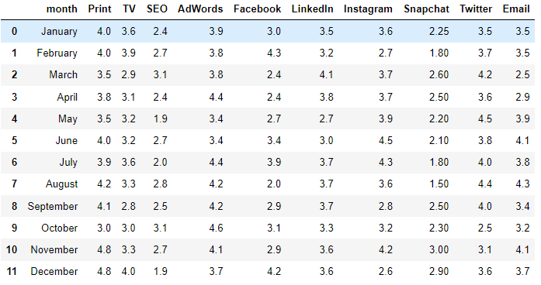

We got the following monthly funds allocation. As we can see from the table, the funds allocation becomes ***‘unstable’*** by definition of change of over 1 million dollars from month to month for almost all mediums other than SEO and SnapChat, which stays 0 throughout the year.

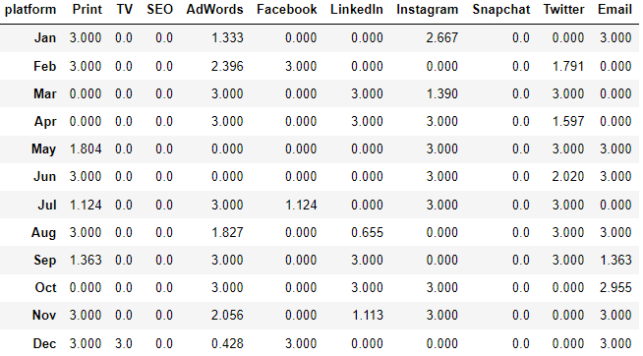

This chart summarizes the month to month change in funds with ‘unstable’ changes of over 1 million highlighted in orange:

Additionally, we can see the overall funds growth based on the optimized allocation based on the 2 ROI assumptions, where the constant ROI assumption would give us an overall higher return at the end of the 12 month period.

